**AHMED HAMED ALY**

18308279

DATE: 16/NOV/2018

LAB: LG35/36

TIME: 4PM TO 6PM

**Introduction**

The experiment consisted of five main parts,

(A) Connecting a circuit using the circuit diagram provided in the question.

(B) Noting the input and output voltages of the circuit.

(C) Connecting another circuit using the circuit diagram.

(D) Noting the input and output voltages of the circuit.

(E) Identifying the truth table for circuit 1 and circuit 2.

There was a couple of factors I had to consider before starting the experiment. These included,

Using working apparatus that has been tested before and won’t cause an error in my result;

Understanding what a transistor is and how it functioned in comparison to the rest of the circuit. A transistor is a semiconductor device with three connections, Drain, Gate and Source (picture shown below).

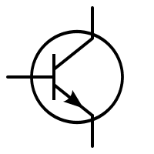

Transistor

**Objective**

The objective of the experiment is to create a circuit to show that an E-MOSFET can be used as a NOT gate and when two E-MOSFETs are placed in series, they can be used as a NAND gate.

**Apparatus**

The apparatus used for the experiment (shown below) were vital to producing the results I acquired from the experiment.

 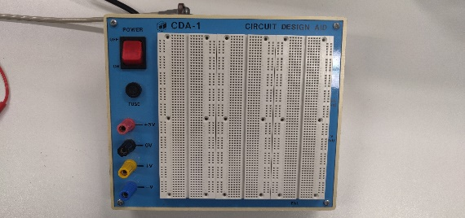

LED Breadboard

 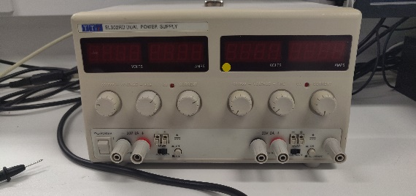

1kΩ Resistor Power Supply

 Transistor

**Method**

1. Connect the circuit (**CIRCUIT 1**) in the diagram shown below.

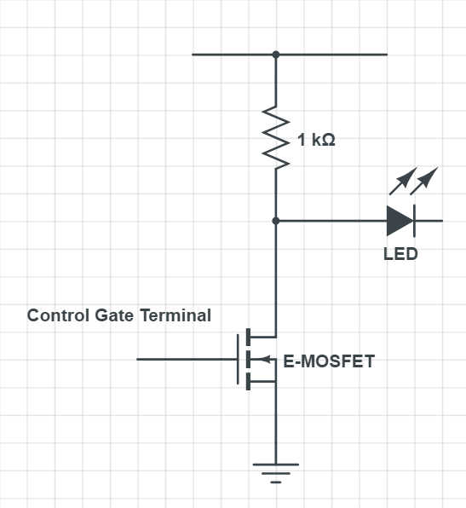

1. Record the input and output voltage and construct a truth table to verify your observation.
2. Connect the circuit (**CIRCUIT 2)** in the diagram shown below.

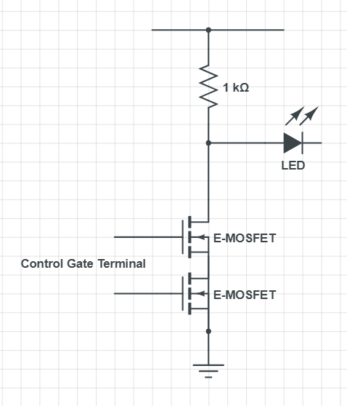

1. Record the input and output voltage and construct a truth table to verify your observation.

**Data/Graph**

*Output = 0, LED off*

*Output = 1, LED on*

**Circuit 1:** Inverter Circuit

NOT GATE

|  |  |
| --- | --- |
| Ainput | Output |
| 1 | 0 |
| 0 | 1 |

**Circuit 2:** Transistor NAND gate Circuit

NAND GATE

|  |  |  |
| --- | --- | --- |
| Ainput | Binput | Output |
| 1 | 1 | 0 |
| 1 | 0 | 1 |
| 0 | 1 | 1 |
| 0 | 0 | 1 |

**Data Analysis**

Based off my results for circuit 1, I verified that the circuit was creating a NOT gate truth table. Whenever the circuit was getting an input voltage, the LED wasn’t lighting up while when the circuit was getting no input voltage, the LED was lighting up. This can be explained as the E-MOSFET acts as an open circuit when it’s in the cut off region as the input voltage is zero and the drain current is also zero.

Vds = Vdd = 1, Vgs < Vgsth

The E-MOSFET is biased which means that the maximum voltage is applied to the gate voltage so Rds is small which means the maximum current flows from the drain through the transistor so it closes the circuit.

Based off my results for circuit 2, I verified that the circuit was creating a NAND gate truth table. Whenever the two transistors were inputting a voltage, the LED remained off, while any other combination for the two transistors in series caused the LED to light up. The circuit worked as two E-MOSFETs in series, so it was a NOT gate going through another NOT gate which created a NAND gate.

If for example you increased the value of the resistor from 1kΩ to 5kΩ, it decreases the output voltage so the LED will become less bright.

**Conclusion**

In conclusion, I was able to verify that for circuit 1, it acted as an inverter (NOT gate) while for circuit 2, it acted as a NAND gate by noting the input voltage and output voltage of both circuits. The experiment worked as expected without any errors.